Unit 5 Final Course Project

C. Bethea

6/11/2020

Final Project with updated changes. README has been updated as well on GUTHUB.

Home Page 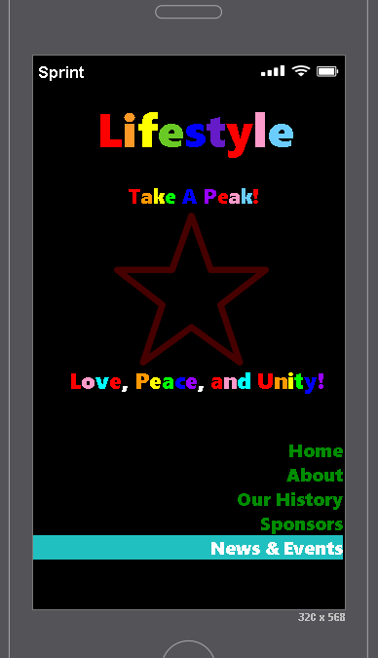

About Page 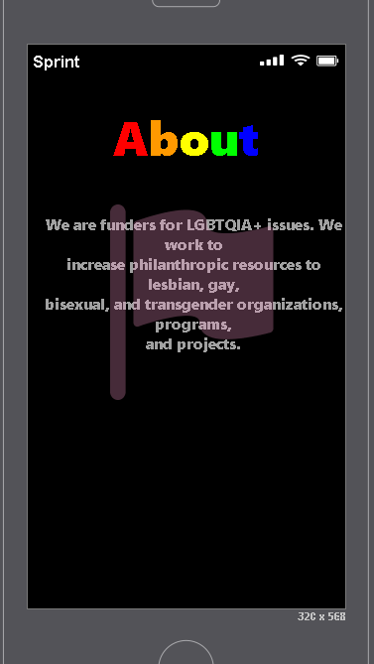

History 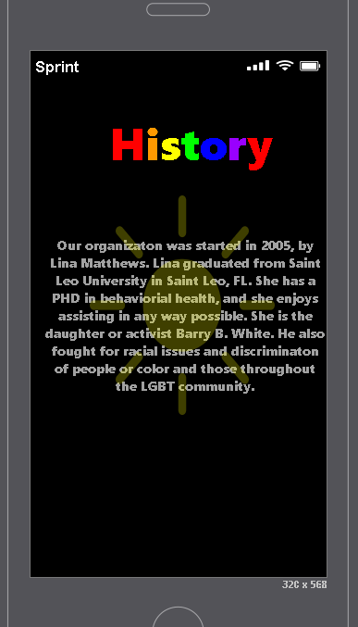

Latest News & Events 

Sponsors 